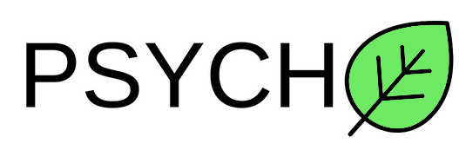

Table of Contents

**Digitalization of the game** 3

Project information and plan 3

Team information 3

Introduction 3

Realization 4

**Work plan** 5

Tasks for completion 5

Digitalization of the game

**Project Information**

* We created the “Mathle” math game using C++, over the span of a month.

**Team Information**

|  |  |
| --- | --- |
| № | Roles in the team |
| 1 | Ivan Andreev – Scrum Trainer |
| 2 | Boyan Kiovtorov – Backend Developer |
| 3 | Dimitur Dimov – Frontend Developer |
| 4 | Dobril Peev – QA Engineer |

**Introduction**

|  |  |
| --- | --- |
| № | Introduction |
| 1 | **What is the product?**  The product is used for educational purposes.It is about chemical elements and how they interact with each others. |
| 2 | **How can you access it?**  You can read about our collaborative work on GitHub and access our project’s repository files. |
| 3 | **What about communication?**  We communicated through Teams due to its helpful functions like screen sharing and text channels. The team was well connected and the work was efficient. |
| 4 | **What programs were used?**  We used GitHub for file management and collaborative work, Visual Studio Code for code editing, MS Teams for communication, MS PowerPoint for our presentation, MS Word for the documentation, MS Excel for our QA documentation. |

**Ways of Realization**

|  |  |
| --- | --- |
| № | How did we do it? |
| 1 | **Task Distribution**  The Tasks were distributed based on the skillset of everyone. We also notified each other when a commit was made so everyone can stay up to date with the collaborative work. This way our team was as productive as possible. |
| 2 | **Task Completion**  Every day we held a meeting to track the development of the app and help each other progress further. We also resolved issues and shared ideas. |
| 3 | **Deadlines**  In these meetings we also discussed time management, how specific parts were coming along, what everyone had done in their specified time and what things should be completed in the near future. |

WORK PLAN

**Tasks for Completion**

|  |  |
| --- | --- |
| № | Task Breakdown |
| 1 | **Creating the main menu**  The main menu was created by our Backend developers and our QA Engineer. It is used to navigate through the application. |
| 2 | **Creating the slider**  The slider was created by our backend developers. The design was made by our backend developer. The slider is used to see how the temperature changes. |
| 3 | **Creating the option menu**  The option menu was created by our Backend developer. It is used to change the settings. |
| 4 | **Creating the periodic table**  The periodic table was created by our Backend developer.It is used to look up to different chemical elements. |
| 5 | **Creating README**  The README was created by our Scrum Trainer.It is used to show off basic information about the team . |
| 6 | **Creating the QA Documentation**  The QA Documentation was created by our QA Engineer. There are unit test reports about the application. |
| 7 | **Documentation**  Our QA Engineer and our Scrum trainer created the documentation using MS Word to summarise the application. |
| 8 | **Presentation**  The presentation was created by our Scrum trainer to explain the concept of the application. |